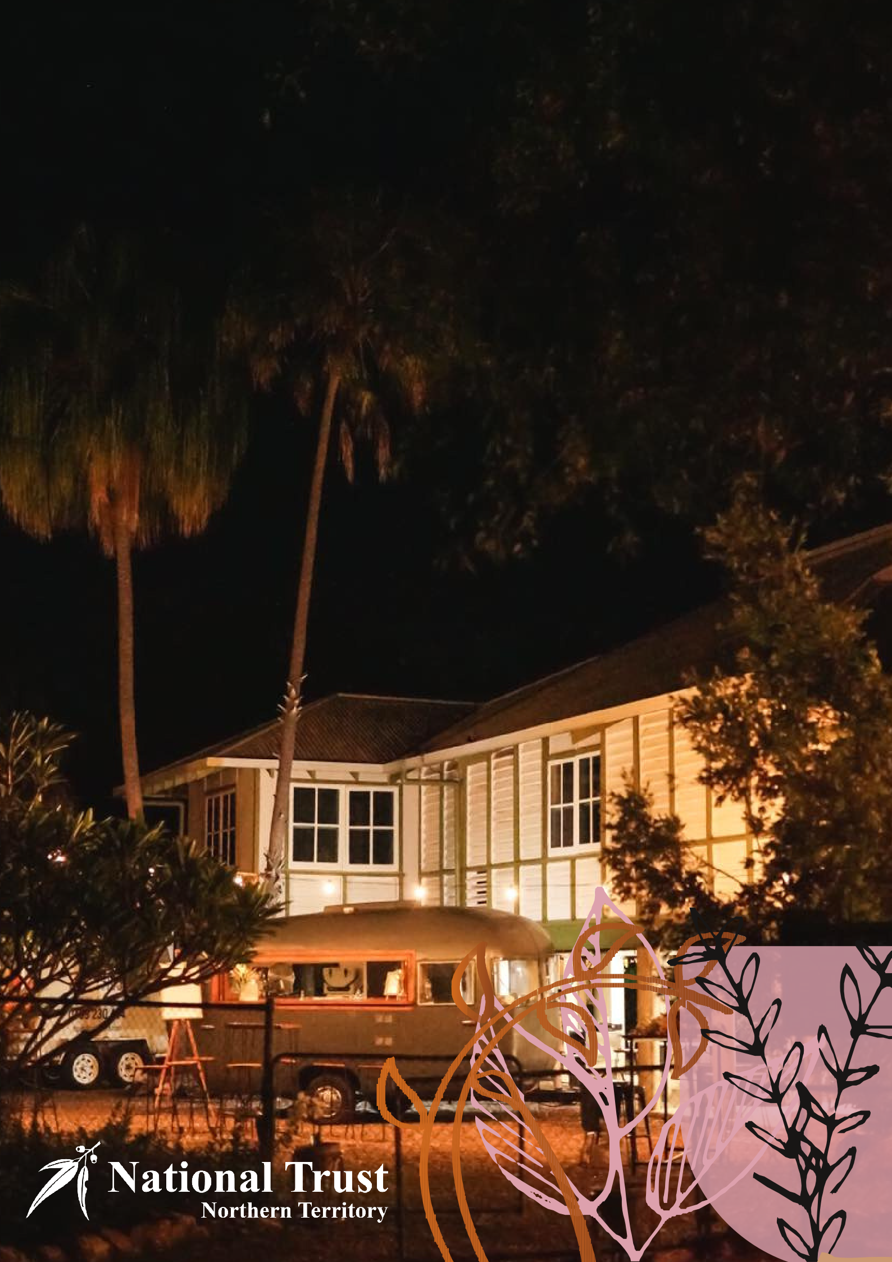
VENUE HIRE
Myilly Point Heritage Precinct
FOR YOUR EVENT OR SPECIAL OCCASION 2027

HERITAGE LISTED BURNETT HOUSE AND AUDIT HOUSE ARE SET IN BEAUTIFUL GARDENS AND ARE THE IDEAL VENUES FOR YOUR EVENT OR SPECIAL OCCASION.
Myilly Point Heritage Precinct
The historical charm and its proximity to the centre of Darwin City make the Myilly Point Heritage Precinct an ideal venue for weddings, receptions, exhibitions and private events.
Appointed as the Commonwealth Government principal architect in the Northern Territory in 1937, Beni Burnett is credited with being one of the first architects to design appropriate houses for Australia's tropical north. Burnett created a series of house designs including those at Myilly Point, which were designated by an ‘alpha numerical’ system.
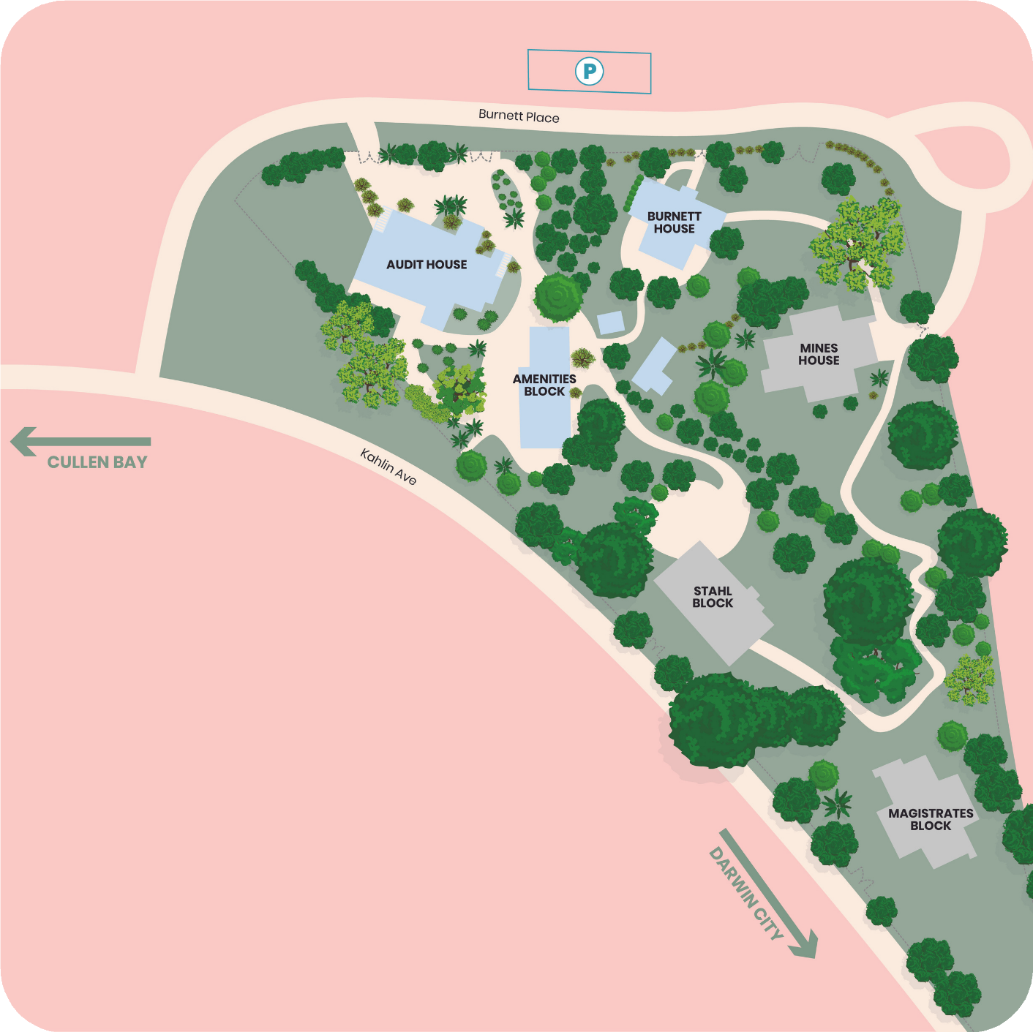
Heritage listed Burnett House (gardens only) and Audit House (house and garden) are available to hire for your event. Access to both properties is via Burnett Place and free parking is available on Burnett Place and along Kahlin Avenue.
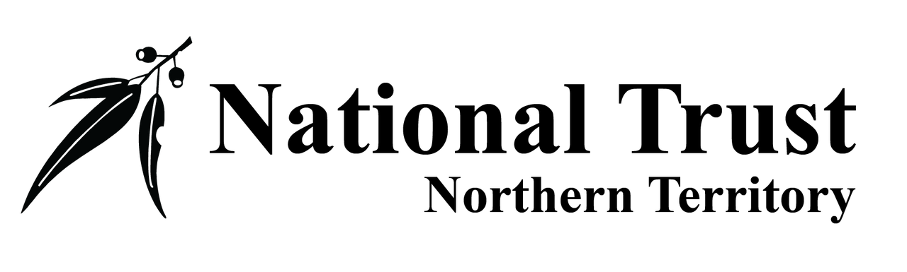
Burnett House
Burnett House is the most well-known house designed by Beni Burnett, offering a little bit of Singapore in the Top End. Built in 1938, it is the only remaining 'Type K' style house in Darwin and is unusual in being of a two-story configuration.

The lush gardens and lawn of Burnett House feature an attractive border of colourful evergreen shrubs. Crotons, frangipanis, bougainvillea and ficus add colour to the tropical feel of the garden and turn this urban rainforest into a private hideaway. A perfect place for a wedding and reception or special event. Note: No parking vehicles on the lawns.
Pricing and Facilities
Capacity | Power | Lighting & Sound | Amenities | Fees  (incl. GST)
Burnett House Garden only  A maximum of 100 people seated | 1 x 10amp single power outlet  1 x 15amp double power outlet  1 x 32amp 3 phase power outlet accessible by arrangement | Flood lighting available  Overhead wires installed for festoon/other lighting or decoration (hirers to provide lighting) | Access to toilet block  (male, female and accessible toilets)  - Use of Audit House Amenities kitchen facilities on arrangement (refrigerator, dish washer microwave, urn)  $150 per day | Minimum hire 3 hours  Monday to Friday $352, thereafter $90 per hour  Saturday & Sunday $396, thereafter $110 per hour  $130 cleaning fee  $350 Security Bond  $50 key deposit
Use of gardens or house for photography purposes only |  |  |  | $100 per hour

Audit House

Audit House was built for the Commonwealth Auditor in 1938. The house is designated ‘Type B’ and is another rare surviving example of 1930s architecture in Darwin.
With its louvred walls, tropical garden and ocean views, you can't beat Audit House as a statement event location. Perfect for small functions, art exhibitions, musical and theatre events. We can now also offer a space for business meetings with video conferencing equipment.
Pricing and Facilities
NewPortRcheyFL34653
Capacity | Power | Lighting & Sound | Amenities | Fees  (incl. GST)
Audit House  (House and Gardens)  House: 60  Garden:  Maximum of 80 people seated.  Use of house or gardens for photography purposes only  Video conferencing equipment  Stahl Block | 3 x 10amp single power outlets (internal)  3 x 15amp general power outlets (external)  - Set up Catering Vans /Fridges etc.  - Function on grounds | Festoon lighting installed in garden area, access by arrangement.  Lighting in house  Use of Power etc. | Access to toilet block (male, female and accessible toilets)  Use of Audit House Amenities kitchen facilities on arrangement (refrigerator, dish washer microwave, urn)  $150 per day | Minimum hire 3 hours  Monday to Friday $352, thereafter $88 per hour  Saturday & Sunday $396, thereafter $99 per hour  $130 cleaning fee  $350 Security Bond  $50 key deposit  $66 per hour  $ 25 per hour  $50 per day
Note: all access for catering vans etc. is via second gate on the back of Mines House at the end of Burnett Place via foot path. Lift up bollard to gain access.

Booking Procedure

STEP 1

Read the National Trust NT Terms & Conditions on page 7 of this brochure.

STEP 2
Arrange a site inspection of your preferred venue/s. Bookings will not be accepted unless a site visit has occurred.
The National Trust NT office is open Monday to Friday from 9am to 2pm. Please email or phone to book your visit:
email: admin@ntnationaltrust.org.au or phone: (08) 8981 2848

STEP 3
Complete and return the Hire Agreement to admin@ntnationaltrust.org.au and make payment of the $100.00 hire deposit (deducted from final invoice) plus $350.00 refundable security Bond to secure your booking. Your booking will then be confirmed in writing and an invoice sent for the balance owing, due 28 days prior to your event.

Payment Details for Hire Deposit
A/C: National Trust of Australia (NT) BSB: 035 302
Account No: 482 877
Please provide your surname and/or name of the event in the banking reference section.

STEP 4
Provide the National Trust NT via email the details of any planned temporary fixtures e.g. lighting, marquees, mobile catering vans.

STEP 5

Pay the invoice issued by National Trust NT in full within 28 days of your hire date/s.

After your hire

The security bond along with key deposit if applicable will be refunded the first Wednesday after the event on the venue and keys being returned in good order. Please include your bank details on the Hire Agreement Form to allow processing of the refund.

Myilly Point Venue Hire Agreement

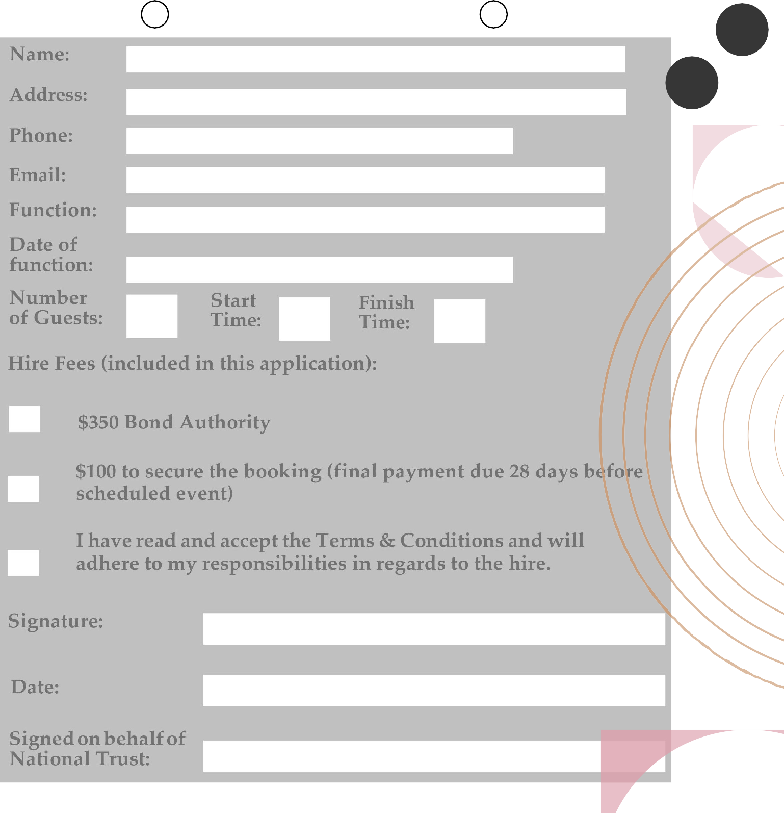
AUDIT HOUSE BURNETT HOUSE GARDENS

Bank Details for bond refund: Account Name: ..................................................................

BSB: ......................... Account No: ...........................................

Myilly Point Heritage Precinct, PO Box 3520, Darwin NT 0801
Tel: (08) 8981 2848 Email: admin@ntnationaltrust.org.au

Terms and Conditions

CONFIRMATION:
All bookings must be confirmed in writing within
14 days of the initial booking. Management reserves the right to cancel any unconfirmed bookings. Final number of guests must be confirmed within seven days of the event.

DEPOSIT:
When you confirm your event, a deposit of $100 will be required to hold the requested date. Final payment is due 28 days before the scheduled event.

BOND:
A signed bond authority of $350 is payable when you confirm your booking and will only be invoked if the area is not returned in good order. Good order includes rubbish and furniture removal within the timeframe outlined in Your Responsibilities.

KEY COLLECTION

Key collection must be organized during the

opening hours of the National Trust NT office

Monday to Friday 9am to 2pm. Keys must be

returned during office hours of the National Trust

NT office on the day following a weekday event

Or Monday following a weekend event.

CANCELLATIONS:
Cancellations must be made in writing to take effect. Cancellations made within 28 days of the event date will forfeit the $100 deposit paid at the time of booking.

Your Responsibilities

Venues must only be used for the purpose described in the hire agreement.
The National Trust has a strict no-smoking policy inside its buildings. Hirers are expected to adhere to this policy. This includes cigarette butts in the gardens which must be removed.
When hiring Burnett House for photographs, no drink or food is permitted inside.
Houses and gardens are leased in a clean, neat, and tidy condition and the hirer is responsible for leaving the venue in the same condition as hired in. A $130 cleaning fee is applicable to all events. (for Cleaning the Amenities block) and separately for Audit house if used.
No ice is to be tipped onto grassed areas (it 'burns' the grass), please dispose of ice in the graveled areas. No vehicles are to be driven on lawns within the house gardens.
All sites is to be cleaned by the hirer on the day / evening of the event ( all food waste removed) and or all rubbish and items removed /secured prior to 9am the following morning .(i.e. lights / tables unless a previous agreement has been made) 1 x general rubbish bin and 1 x recycle bin will be provided for hirer use; any additional rubbish must be removed by the hirer.
Please be respectful of our neighbors regarding noise levels. The NT Trust is not in the business of delivering music events and therefore should the hirer plan to provide music during the hire-event, the hirer must obtain the appropriate Licence and comply with prevailing music-copywrite law relevant to that event.
Music is to be turned down to a suitable level from 10 pm and off by 11 pm.
The National Trust is not responsible for the setup of external suppliers and/or decorations. All external suppliers must provide all equipment necessary, such as power leads/power boards (must be tested and tagged), and any other necessary items.
- The National Trust is not responsible for the safeguarding of any equipment on the NT Trust grounds.
Food venue Vehicles may park on Stahl Block entrance via Mines house rear gates, lift bollard in footpath and reinstate. Do not park or drive on Stahl Bricks .

