


Comments on the provisional registration of Wybalena Grove Precinct
***please note that only comments received during the public consultation period will be valid for certain provisions under section 13 and/or review under part 17 of the Heritage Act 2004. This includes comments received no earlier than 12am on 8 April and no later than 11:59pm on 5 May 2026***
Background
The Council has provisionally registered Wybalena Grove Precinct to indicate that it intends to decide on whether to permanently include it on the ACT Heritage Register.
The provisional registration sets out Wybalena Grove Precinct’s heritage values that the Council thinks are important to the ACT and why. This public consultation is to hear the views of the ACT community.
The provisional registration states Wybalena Grove Precinct meets the following criteria under the Heritage Act 2004:
(a) importance to the course or pattern of the ACT’s cultural or natural history
(b) has uncommon, rare or endangered aspects of the ACT’s cultural or natural history
(d) importance in demonstrating the principal characteristics of a class of cultural or natural places or objects
Please read the provisional registration decision and the background information documents before starting.
Privacy statement
This document fulfils the role of public consultation under section 37 of the Heritage Act 2004 (the Act), and the collection of personal information as authorised by the Act.
If you make a comment, you will be considered an interested person under section 13 of the Act. For this reason, respondents are asked to provide contact details so functions under the Act relating to notification of interested persons can be fulfilled.
If you do not provide your identity or contact details the ACT Heritage Council will be unable to give you notice of decisions as an interested person. Also, you may not be able to be identified as an interested person entitled to appeal rights under the Act.
The personal information on this survey is collected by the Environment, Planning and Sustainable Development Directorate (EPSDD) and provided to the ACT Heritage Council.
All personal information provided will be collected, used and stored in accordance with the Information Privacy Act 2014, EPSDD’s Information Privacy Policy and EPSDD’s Information Privacy Policy - Annex.
These documents contain information about how you may access or seek to correct your personal information held by EPSDD and how you may complain about an alleged breach of the Territory Privacy Principles.

Section 1 - ACT Heritage Council considerations – Wybalena Grove Precinct
The boundary on the map (Figure 1) and the attributes listed below identify the proposed heritage values of Wybalena Grove Precinct.
Do you agree with the following values or do you have changes you want the Council to consider?
- Arrangement of single, split level, and tri level houses in parallel terrace clusters with irregular offsets
- Communal facilities and common areas
- Network of pedestrian pathways, open spaces, transition zones and nature corridors
- General alignment and positioning of roads and shared car parks to encourage social interaction and minimise vehicle intrusion
- Integration of structures within a natural bushland environment, including a mixture of both Australian native and exotic flora
- Steeply pitched gabled roofs in alignment with triangular wingwalls
- Siting of houses within the sloping topography, with a northwestern aspect
- Use of a cohesive dark colour palette and natural materials, or substitutions consistent with the original design intent
- Dark stained timber awning sash windows and clerestory windows
- Community governance structure, governance systems and processes as set out in Wybalena Grove guidelines and policy documents
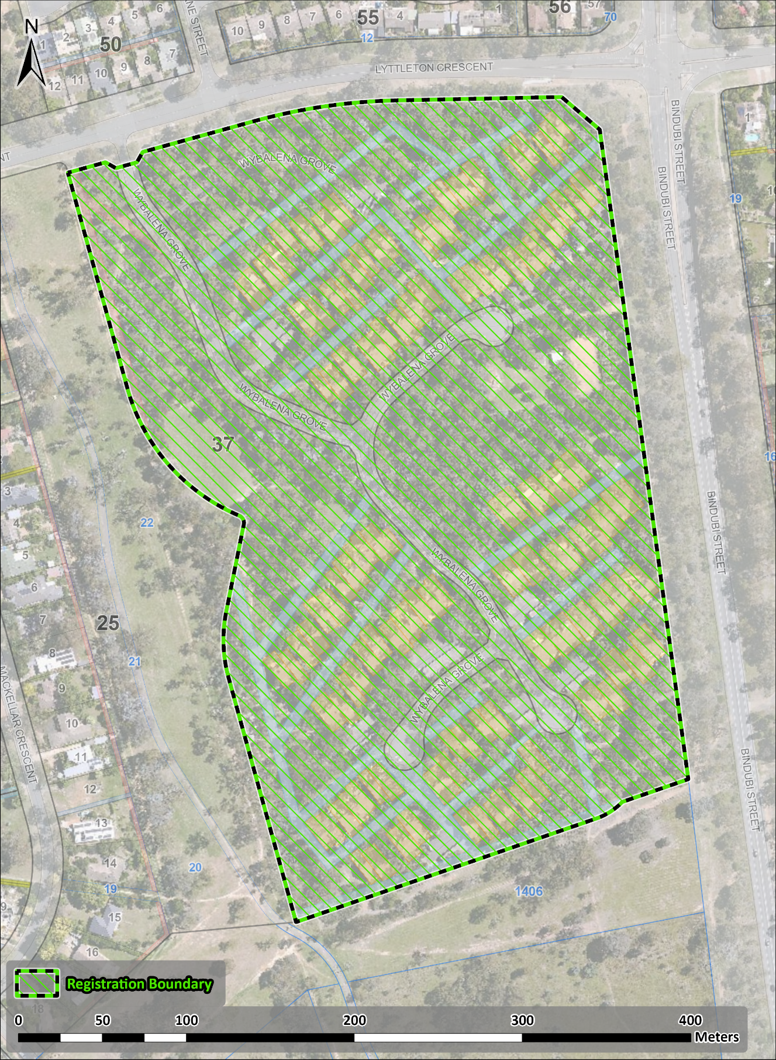
Figure 1 – Proposed Wybalena Grove Precinct Heritage Boundary

Your Comments on the proposed boundary and features that describe the significant attributes of the place:
Click here to enter text.

Section 2 - ACT Heritage Council considerations - significance
A place or object has heritage significance if it meets with one or more of the eight heritage significance criteria as defined under section 10 of the Heritage Act 2004.
The heritage significance criteria are labelled (a) to (h). Your comments are most useful when addressed against each of these criteria or when focusing on the ones relevant to your argument. However, you may choose to only leave a general comment by skipping to the General Comments section.
The ACT Heritage Council has determined that Wybalena Grove Precinct is likely to have heritage significance under criteria (a), (b), and (d) only. The criteria that are not met can also be commented on.
Table 1 Criteria that the Council consider have been met.
Criterion | (a) | (b) | (c) | (d) | (e) | (f) | (g) | (h)
Met | Yes | Yes | No | Yes | No | No | No | No
While the Council will independently assess and research any claims you make against the criteria, it may be helpful to refer to the Heritage Assessment Policy as a guide to providing the strongest argument with appropriate evidence.

(a) importance to the course or pattern of the ACT’s cultural or natural history
MEETS CRITERION.
The Council is satisfied on reasonable grounds that the place is likely to meet this criterion.
Wybalena Grove, established by the Cook Aranda Co-operative Housing Society (CACHS) in the 1970s and designed in the Sydney Regional Style by architect Michael Dysart, is important for its association with the post-war period and co-operative housing movement in the ACT. This movement emerged during a period of intensified building efforts by the National Capital Development Commission (NCDC) to meet the residential housing needs of a dramatically increasing population during the post-war period. Although the NCDC was initially resistant to the idea of co-operative housing, the concept was ultimately supported as a housing solution for Canberra’s growing population.
Housing demand and rising construction costs presented an opportunity for innovation in residential architecture. This period saw the proliferation of modernist and experimental residential housing in the ACT, including the peak period of interest in co-operative housing and the broader ‘golden age’ of the co-operative movement in Australia. Wybalena Grove has a distinctive association with this period of development. It is the larger of 2 co-operative housing ventures that emerged in the 1970s in the ACT, the other being Urambi Village in Kambah, also designed by Michael Dysart. The completion of Wybalena Grove is also closely tied to changes in Territory planning legislation and the wider climate of social reform associated with the Whitlam government.
Wybalena Grove reflects the progressive ethos and aspirations of the co-operative housing movement for affordable community living in harmony with the natural environment. In particular, it reflects an attempt to generate a sense of community during a period of change and growth for the capital. Community focussed living balanced with the need for privacy is evident in the design of Wybalena Grove. Key design features include clustered parallel terraces with irregular offsets, communal facilities and common areas, a network of pedestrian pathways, and the general alignment and positioning of roads and car parks to encourage social interaction. The use of a cohesive dark colour palette and natural materials, siting of dwellings within the sloping topography, nature corridors, open spaces and transition zones, and extensive landscaping all contribute to the overall sense of community living within a natural environment.
Historical documents demonstrate that Wybalena Grove has been highly successful at fostering a sense of community for its residents, and it remains a popular cooperatively managed residential complex today. This includes a governance structure that supports community decision-making regarding development, alterations and repairs at the complex.
Wybalena Grove meets the threshold indicators of rarity and representativeness. It is evidence of the golden age of the co-operative housing movement in the ACT.

Your comments on criterion (a):
Click here to enter text.

(b) has uncommon, rare or endangered aspects of the ACT’s cultural or natural history
MEETS CRITERION.
The Council is satisfied on reasonable grounds that the place is likely to meet this criterion.
Wybalena Grove is 1 of only 2 20th century co-operative housing projects in the ACT, the other being Urambi Village in Kambah, also designed by Michael Dysart.
The success of Wybalena Grove is closely tied to the political, economic, and social climate of the ACT in the early 1970s, during the peak of the co-operative housing movement in Australia. At this time, at least 14 housing co-operatives were registered in the ACT, however only Wybalena Grove and Urambi Village resulted in completed projects.
Following this peak of activity housing co-operatives significantly declined, and the movement did not materialise into a strong housing alternative in Australia due to financial, legislative and cultural shifts. While there is contemporary interest in alternative and co-operative housing models as an affordable and sustainable housing solution, there are no other known successfully completed co-operative housing projects in the ACT from the 20th century.
The ambitions of the co-operative movement are captured in the original design intent for Wybalena Grove and remain evident in the layout and built fabric of the place. This includes elements of co-housing design, such as clustered housing, minimal vehicle intrusion, communal spaces, and a network of pedestrian pathways.
Wybalena Grove meets the threshold indicator of rarity and intactness as evidence of the golden age of the co-operative housing movement.

Your comments on criterion (b):
Click here to enter text.

(c) potential to yield important information that will contribute to an understanding of the ACT’s cultural or natural history
Does not meet criterion.
The Council is not satisfied on reasonable grounds that the place is likely to meet this criterion.
There is no evidence to suggest that Wybalena Grove will yield substantial new information about the ACT’s cultural or natural history beyond what is currently known through historical documentation, or visible in the built fabric of the place.

Your comments on criterion (c):
Click here to enter text.

(d) importance in demonstrating the principal characteristics of a class of cultural or natural places or objects
MEETS CRITERION.
The Council is satisfied on reasonable grounds that the place is likely to meet this criterion.
Wybalena Grove is a distinctive example of the modernist Sydney Regional architectural design style in the ACT, being 1 of only 2 examples where this was applied to a co-operative housing venture (the other being Urambi Village in Kambah).
Design elements of the Sydney Regional Style are evident in the layout, materials, and landscaping of Wybalena Grove, designed by architect Michael Dysart. This is expressed through the sympathetic arrangement of houses in parallel terrace clusters along the sloping topography of the site and consistent application of dark, natural materials to match the colour palette of a bushland setting. Houses were originally positioned around patches of remnant native vegetation, and extensive planting efforts undertaken by Wybalena Grove residents since its construction have contributed to an overall sense of residential living within a natural bushland environment.
Visual harmony with the natural environment and the sloped topography is similarly expressed with split level designs and the use of dark toned natural materials. Rather than the typical Sydney Regional Style skillion roof, steeply pitched gabled roofs connect with wingwalls between houses, extending triangular lines to the ground. The overall visual effect is complementary to the sloping topography. The use of natural, textured materials includes dark brick, dark stained exposed timber, and dark tiles. Dark stained timber awning sash windows and clerestory windows are also features of the Sydney Regional Style incorporated at Wybalena Grove.
Wybalena Grove is notable as an unusual example of the Sydney Regional Style when compared to other examples in the ACT due to the application of this design to a large community focussed housing project. Several distinctive design elements have been applied to encourage a sense of community, while balancing individual privacy. This includes the arrangement of houses in 5 clusters, integrated with communal facilities such as a playground, village green, tennis court, community garden, and barbeque spaces. The general alignment and positioning of roads, shared car parks, and pedestrian pathways also encourages interaction between community members when moving throughout the complex. At the same time, privacy is provided by the irregular offsets of houses within a terrace row, as well as by large triangular wingwalls between houses.
The layout of Wybalena Grove has remained largely unchanged since its construction in the 1970s. Additions and alterations, while common throughout the precinct, have predominantly been carried out in keeping with the original design principles, maintaining a visual cohesion of dark, natural materials and triangular forms across the site.
Wybalena Grove has been recognised and celebrated for its modernist design, receiving the Sir Roy Grounds Award for Enduring Architecture in 2019 from the Australian Institute of Architects. Wybalena Grove has also featured in art and design print, digital, and televised media for its modernist features, bushland setting, and community living.
Wybalena Grove meets the threshold indicator of distinctiveness through the application of the Sydney Regional Style of architecture to a co-operative housing project.

Your comments on criterion (d):
Click here to enter text.

(e) importance in exhibiting particular aesthetic characteristics valued by the ACT community or a cultural group in the ACT
Does not meet criterion.
The Council is not satisfied on reasonable grounds that the place is likely to meet this criterion.
There are no known distinctive aesthetic characteristics at Wybalena Grove that are valued by a specific cultural group in the ACT or by the ACT community more broadly.
The threshold indicator of ‘valued by the ACT community’ must be objectively tested and/or clearly demonstrated. While Wybalena Grove is valued among architects and those passionate about architecture, this does not qualify as the broader ACT community nor a cultural group.

Your comments on criterion (e):
Click here to enter text.

(f) importance in demonstrating a high degree of creative or technical achievement for a particular period
Does not meet criterion.
The Council is not satisfied on reasonable grounds that the place is likely to meet this criterion.
While Wybalena Grove displays a considered use of materials to complement the natural topography and foster community living, this reflects broader trends in the creative and technical innovations of modernist architectural design, including the wider practice of architect Michael Dysart and other Sydney Regional Style designers. The level of creative and technical achievement displayed at Wybalena Grove is neither exceptionally important nor of an unusually high degree for its time.

Your comments on criterion (f):
Click here to enter text.

(g) has a strong or special association with the ACT community, or a cultural group in the ACT for social, cultural or spiritual reasons
Does not meet criterion.
The Council is not satisfied on reasonable grounds that the place is likely to meet this criterion.
There are no known special or strong associations between Wybalena Grove and a specific cultural group in the ACT.

Your comments on criterion (g):
Click here to enter text.

(h) has a special association with the life or work of a person, or people, important to the history of the ACT
Does not meet criterion.
The Council is not satisfied on reasonable grounds that the place is likely to meet this criterion.
There are no known special associations between Wybalena Grove and the life or work of a specific person important to the history of the ACT.
Sydney architect Michael Dysart is an accomplished and celebrated modernist architect of the Sydney Regional Style, who also designed Urambi Village in Kambah. Dysart played an important role in designing educational buildings and public housing in New South Wales as a NSW Government Architect. In this role Dysart was responsible for the design of at least 43 schools across NSW. Dysart also designed the Lowline home, the first architect-designed project home for Pettit & Sevitt displayed in 1963 at the Rocks in Sydney. There are many examples of the Pettit and Sevitt Lowline home in Canberra, as well as other project homes designed by Dysart with the company Aspect and Habitat in Aranda, Kambah and Weston.
To meet this criterion, the association between the person and the place must be enduring, beyond the ordinary, and differentiated from other similar places associated with the person. The life or work of that person must also be important to the history of the ACT.
Although the association of Wybalena Grove with Dysart is a close one, Dysart is best recognised for his work in New South Wales. There is no known special association between Dysart and Wybalena Grove beyond the commissioning of the design.

Your comments on criterion (h):
Click here to enter text.

Section 3 – General comments
Enter here any information or to make a general comment about the proposed provisional registration that does not address any of the criteria. Remember that the outcome of the heritage assessment is directly linked to the criteria and submissions are more likely to affect the outcome if they specifically address the criteria and the Council’s proposed assessment against them.
I support the proposed heritage registration? Choose an item.
Please include any further comments to your submission:
Click here to enter text.

Section 4 - Demographics
Your personal details are confidential and will not be publicly visible, but this is required for you to be kept informed and to be counted as an ‘interested person’ (refer to the Privacy Statement at the beginning of the document).
If you do not provide your identity or contact details, then the ACT Heritage Council will be unable to give you notice of decisions as an interested person under the Act. Also, you may not be able to be identified as an interested person entitled to appeal rights under the Heritage Act 2004.
First Name: Click here to enter given name.
Last Name: Click here to enter surname.
Preferred contact details (phone, email, postal address):
Click here to enter address.
Age range: Click to choose an age range.
Relationship to the place: Click to choose a category.
Have you ever provided comments on other heritage registrations? Click to select.

What next?
After you have saved this form, it can be emailed to heritage.registrations@act.gov.au or printed and mailed to:
The Secretary
ACT Heritage Council
GPO Box 158
Canberra City ACT 2601

