
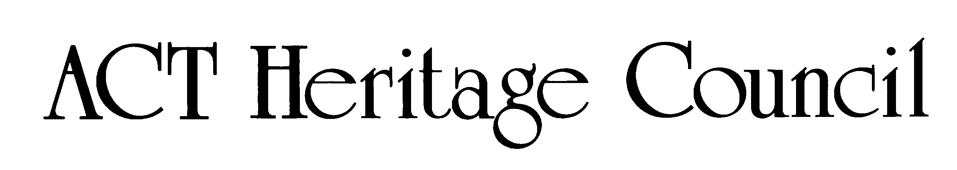

Comments on the provisional registration of Urambi Co-operative Housing Precinct
***please note that only comments received during the public consultation period will be valid for certain provisions under section 13 and/or review under part 17 of the Heritage Act 2004. This includes comments received no earlier than 12am on 8 April and no later than 11:59pm on 5 May 2026***
Background
The Council has provisionally registered Urambi Co-operative Housing Precinct to indicate that it intends to decide on whether to permanently include it on the ACT Heritage Register.
The provisional registration sets out Urambi Co-operative Housing Precinct’s heritage values that the Council thinks are important to the ACT and why. This public consultation is to hear the views of the ACT community.
The provisional registration states Urambi Co-operative Housing Precinct meets the following criteria under the Heritage Act 2004:
(a) importance to the course or pattern of the ACT’s cultural or natural history
(b) has uncommon, rare or endangered aspects of the ACT’s cultural or natural history
(d) importance in demonstrating the principal characteristics of a class of cultural or natural places or objects
Please read the provisional registration decision and the background information documents before starting.
Privacy statement
This document fulfils the role of public consultation under section 37 of the Heritage Act 2004 (the Act), and the collection of personal information as authorised by the Act.
If you make a comment, you will be considered an interested person under section 13 of the Act. For this reason, respondents are asked to provide contact details so functions under the Act relating to notification of interested persons can be fulfilled.
If you do not provide your identity or contact details the ACT Heritage Council will be unable to give you notice of decisions as an interested person. Also, you may not be able to be identified as an interested person entitled to appeal rights under the Act.
The personal information on this survey is collected by the Environment, Planning and Sustainable Development Directorate (EPSDD) and provided to the ACT Heritage Council.
All personal information provided will be collected, used and stored in accordance with the Information Privacy Act 2014, EPSDD’s Information Privacy Policy and EPSDD’s Information Privacy Policy - Annex.
These documents contain information about how you may access or seek to correct your personal information held by EPSDD and how you may complain about an alleged breach of the Territory Privacy Principles.

Section 1 - ACT Heritage Council considerations – Urambi Co-operative Housing Precinct
The boundary on the map (Figure 1) and the attributes listed below identify the proposed heritage values of Urambi Co-operative Housing Precinct.
Do you agree with the following values or do you have changes you want the Council to consider?
- Arrangement of split-level and courtyard dwellings in parallel terrace clusters with irregular offsets
- Common facilities and spaces, such as a community centre, swimming pool, and ball court
- Network of pedestrian pathways, open spaces, transition zones and nature corridors
- General alignment and positioning of roads and shared car parks to encourage social interaction and minimise vehicle intrusion
- Integration of structures within a natural environment, including a mixture of both Australian native and exotic flora
- Skillion roofs in alignment with triangular wing walls
- Siting of houses within the sloping topography providing views to the west and north
- Use of a cohesive dark colour palette and natural materials, or substitutions consistent with the original design intent
- Dark stained timber awning sash windows and clerestory windows
- Community governance structure, governance systems and processes as set out in Urambi Village guidelines and policy documents

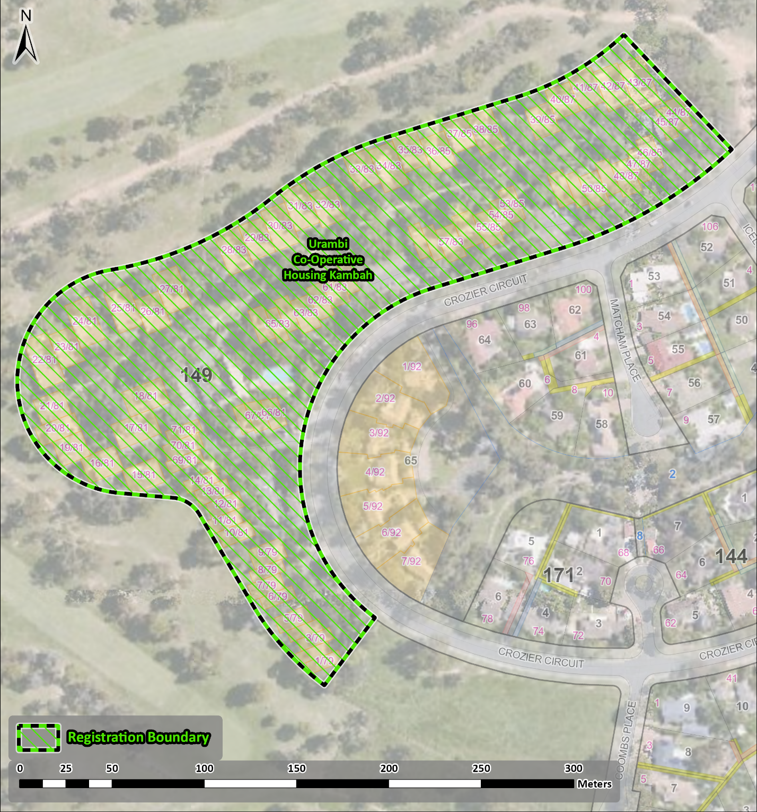
Figure 1 – Proposed Urambi Co-operative Housing Heritage Boundary

Your Comments on the proposed boundary and features that describe the significant attributes of the place:
Click here to enter text.

Section 2 - ACT Heritage Council considerations - significance
A place or object has heritage significance if it meets with one or more of the eight heritage significance criteria as defined under section 10 of the Heritage Act 2004.
The heritage significance criteria are labelled (a) to (h). Your comments are most useful when addressed against each of these criteria or when focusing on the ones relevant to your argument. However, you may choose to only leave a general comment by skipping to the General Comments section.
The ACT Heritage Council has determined that Urambi Co-operative Housing Precinct is likely to have heritage significance under criteria (a), (b), and (d) only. The criteria that are not met can also be commented on.
Table 1 Criteria that the Council consider have been met.
Criterion | (a) | (b) | (c) | (d) | (e) | (f) | (g) | (h)
Met | Yes | Yes | No | Yes | No | No | No | No
While the Council will independently assess and research any claims you make against the criteria, it may be helpful to refer to the Heritage Assessment Policy as a guide to providing the strongest argument with appropriate evidence.

(a) importance to the course or pattern of the ACT’s cultural or natural history
MEETS CRITERION.
The Council is satisfied on reasonable grounds that the place is likely to meet this criterion.
Urambi Village is important for its association with the post-war period and co-operative housing movement in the ACT.
Urambi Village represents the first of only 2 successfully completed co-operative housing projects during the post-war period, which was characterised by rapid population growth and experimentation with alternative housing models.
The project was undertaken between 1974 and 1976 by the Urambi Co-operative Community Advancement Society during a peak period of interest in co-operative housing and the broader ‘golden age’ of the co-operative movement in Australia. The formation of the co-operative is also closely tied to changes in Territory planning legislation and the wider climate of social reform associated with the Whitlam government. Urambi Village reflects the progressive ethos and aspirations of co-operative housing movements for affordable community living in harmony with the natural environment. In particular, it reflects an attempt to generate a sense of community during a period of change and growth for the capital.
The design of the precinct by Michael Dysart demonstrates key features of the co-operative and co-housing movement, incorporating self-contained dwellings within shared community spaces to foster social networks whilst maintaining individual privacy. Key design elements include clustered housing, common spaces and facilities such as a community centre, a network of pedestrian paths, and minimal vehicle intrusion. The precinct also illustrates the Sydney Regional Style of modernist architecture, including a cohesive dark brown colour scheme, siting of houses within sloping terrain, and a natural environment.
These features have been maintained to a high standard by residents, and the precinct has a high degree of integrity. The success of the project and design is evidenced by the strong sense of community that has endured in the village over the past 50 years, embraced by both past and present residents. This includes a governance structure that supports community decision-making regarding development, alterations and repairs at the complex.
Urambi Village meets the threshold indicator of rarity and representativeness as evidence of the golden age of the co-operative housing movement in the ACT.

Your comments on criterion (a):
Click here to enter text.

(b) has uncommon, rare or endangered aspects of the ACT’s cultural or natural history
MEETS CRITERION.
The Council is satisfied on reasonable grounds that the place is likely to meet this criterion.
Urambi Village is the first of only 2 20th century co-operative housing projects in the ACT, the other being Wybalena Grove in Cook.
The success of Urambi Village is closely tied to the political, economic, and social climate of the ACT in early 1970s, during the peak of the co-operative housing movement in Australia. At this time, at least 14 housing co-operatives were registered in the ACT, although only Urambi Village and Wybalena Grove in Cook resulted in completed projects.
Following this peak of activity housing co-operatives significantly declined and the movement did not materialise into a strong housing alternative in Australia due to financial, legislative and cultural shifts. Whilst there is contemporary interest in alternative and co-operative housing models as an affordable and sustainable housing solution, there are no other known successfully completed co-operative housing projects in the ACT from the 20th century.
Urambi Village meets the threshold indicator of rarity and intactness as evidence of the golden age of the co-operative housing movement in the ACT.

Your comments on criterion (b):
Click here to enter text.

(c) potential to yield important information that will contribute to an understanding of the ACT’s cultural or natural history
Does not meet criterion.
The Council is not satisfied on reasonable grounds that the place is likely to meet this criterion.
There is no evidence to suggest that Urambi Village will yield substantial new information about the ACT’s cultural or natural history than what is currently known through historical documentation, or visible in the built fabric of the place.

Your comments on criterion (c):
Click here to enter text.

(d) importance in demonstrating the principal characteristics of a class of cultural or natural places or objects
MEETS CRITERION.
The Council is satisfied on reasonable grounds that the place is likely to meet this criterion.
Urambi Village is a distinctive example of the modernist Sydney Regional Style in the ACT, being the first of 2 examples where this was applied to a co-operative housing venture (the other being Wybalena Grove in Cook).
Design elements of the Sydney Regional Style are evident in the layout, materials, and landscaping of Urambi Village, designed by architect Michael Dysart.
The overall design emphasises integration with the natural environment, including the consistent application of dark, natural materials, and siting of houses within the sloping terrain. Visual cohesion across the village is achieved through the use of a unified palette of dark brown tiled roofs, brickwork, and dark stained timber. Where substitutions of original fabric have been required, material has been chosen that is consistent with the original design intent. Other elements of the Sydney Regional Style include the use of dark stained timber awning sash windows and clerestory windows.
Integration with the sloping landscape is expressed through the arrangement of houses in clustered parallel terrace rows with irregular offsets curved along the sloping topography of the site. The sloping topography of the site is similarly complemented by the use of split-level dwellings along Crozier Circuit and angular lines formed by skillion roofs and wing walls.
Visual harmony with the natural environment is also achieved through meandering pedestrian paths, open spaces, transition zones and nature corridors. Extensive planting efforts undertaken by Urambi Village residents since its construction have contributed to an overall sense of residential living within a natural environment.
Urambi Village is notable as an unusual example of the Sydney Regional Style when compared to other examples in the ACT due to the application of this design to a large community focussed housing project. Elements of co-housing design have been applied to encourage a sense of community, while balancing individual privacy.
The use of clustered housing, common spaces and facilities, a network of pedestrian paths, and the general alignment and positioning of roads and shared carparks encourages interaction between community members when moving throughout the village.
Meanwhile, irregular offsets within each row and the use of wing walls creates privacy between houses as well as forming enclosed or partially enclosed outdoor courtyard spaces. Whilst houses range from 2 to 5 bedrooms in order to support a diversity of household needs, visual harmony is maintained across the village through colour palette and style.
The layout of Urambi Village has remained largely unchanged since its construction in the 1970s. Additions and alterations have been carried out in keeping with the original design principles, maintaining a visual cohesion of dark, natural materials and angular forms across the site.
The success of the design has been recognised with several awards from the Australian Institute of Architects including the CS Daley Medal for Housing in 1977, the ACT Chapter 25-year award in 2002, and recognition on the Register of Nationally Significant 20th Century Architecture.
Urambi Village meets the threshold indicator of distinctiveness through the application of the Sydney Regional Style of architecture to a co-operative housing project.

Your comments on criterion (d):
Click here to enter text.

(e) importance in exhibiting particular aesthetic characteristics valued by the ACT community or a cultural group in the ACT
Does not meet criterion.
The Council is not satisfied on reasonable grounds that the place is likely to meet this criterion.
There are no known distinctive aesthetic characteristics at Urambi Village that are valued by a specific cultural group in the ACT or by the ACT community more broadly.
The threshold indicator of ‘valued by the ACT community’ must be objectively tested and/or clearly demonstrated. While Urambi Village is valued among architects and those passionate about architecture, this does not qualify as the broader ACT community nor a cultural group.

Your comments on criterion (e):
Click here to enter text.

(f) importance in demonstrating a high degree of creative or technical achievement for a particular period
Does not meet criterion.
The Council is not satisfied on reasonable grounds that the place is likely to meet this criterion.
Whilst Urambi Village displays a considered use of the Sydney Regional Style, this reflects broader trends in the creative and technical innovations of modernist architectural design, including the wider practice of architect Michael Dysart and other Sydney Regional Style designers. The level of creative and technical achievement displayed at Urambi Village is not of an unusually high degree for its time.

Your comments on criterion (f):
Click here to enter text.

(g) has a strong or special association with the ACT community, or a cultural group in the ACT for social, cultural or spiritual reasons
Does not meet criterion.
The Council is not satisfied on reasonable grounds that the place is likely to meet this criterion.
Whilst the precinct is highly valued by both past and present residents, there are no known special or strong associations that are demonstrable, enduring, and out of the ordinary between Urambi Village and a specific cultural group in the ACT for social, cultural, or spiritual reasons.

Your comments on criterion (g):
Click here to enter text.

(h) has a special association with the life or work of a person, or people, important to the history of the ACT
Does not meet criterion.
The Council is not satisfied on reasonable grounds that the place is likely to meet this criterion.
There are no known special associations between Urambi Village and the life or work of a specific person important to the history of the ACT.
Sydney architect Michael Dysart is an accomplished and celebrated modernist architect of the Sydney Regional Style, who also designed Wybalena Grove in Cook. In particular, Dysart played an important role in designing educational buildings and public housing in New South Wales as a NSW Government Architect. In this role Dysart was responsible for the design of at least 43 schools across NSW. Dysart also designed the Lowline home, the first architect designed project home for Pettit & Sevitt displayed in 1963 at the Rocks in Sydney. There are many examples of the Pettit and Sevitt Lowline home in Canberra, as well as other project homes designed by Dysart with the company Aspect and Habitat in Aranda, Kambah and Weston.
In order to meet this criterion, the association between the person and the place must be enduring, beyond the ordinary, and differentiated from other similar places associated with the person. The life or work of that person must also be important to the history of the ACT.
Although the association of Urambi Village with Dysart is a close one, Dysart is best recognised for his work in New South Wales. There is no known special association between Dysart and Urambi Village beyond the commissioning of the design, or broader significance of this association to shaping the history of the ACT.

Your comments on criterion (h):
Click here to enter text.

Section 3 – General comments
Enter here any information or to make a general comment about the proposed provisional registration that does not address any of the criteria. Remember that the outcome of the heritage assessment is directly linked to the criteria and submissions are more likely to affect the outcome if they specifically address the criteria and the Council’s proposed assessment against them.
I support the proposed heritage registration? Choose an item.
Please include any further comments to your submission:
Click here to enter text.

Section 4 - Demographics
Your personal details are confidential and will not be publicly visible, but this is required for you to be kept informed and to be counted as an ‘interested person’ (refer to the Privacy Statement at the beginning of the document).
If you do not provide your identity or contact details, then the ACT Heritage Council will be unable to give you notice of decisions as an interested person under the Act. Also, you may not be able to be identified as an interested person entitled to appeal rights under the Heritage Act 2004.
First Name: Click here to enter given name.
Last Name: Click here to enter surname.
Preferred contact details (phone, email, postal address):
Click here to enter address.
Age range: Click to choose an age range.
Relationship to the place: Click to choose a category.
Have you ever provided comments on other heritage registrations? Click to select.

What next?
After you have saved this form, it can be emailed to heritage.registrations@act.gov.au or printed and mailed to:
The Secretary
ACT Heritage Council
GPO Box 158
Canberra City ACT 2601

