

Penitentiary Chapel Historic Site

6 Brisbane Street

HOBART TASMANIA 7000

[m-director@nationaltrusttas.org.au](mailto:m-director@nationaltrusttas.org.au)

**EXPRESSIONS OF INTEREST SOUGHT – BUSINESS PLAN DEVELOPMENT**

**Convict Memorial Hub at the Penitentiary Chapel Historic Site**

The National Trust of Australia (Tasmania, NTT) is seeking Expressions of Interest from individuals prepared to undertake business planning for the development of a Convict Memorial Hub at the Penitentiary Chapel Historic Site (PCHS), located at the corner of Campbell and Brisbane streets, Hobart.

TheTasmanian Government has promised $1.25m for the proposed project, subject to the development of a business plan, with funding being managed by the Port Arthur Historic Site Management Authority (PAHSMA).

Overall the Convict Memorial seeks to make the PCHS central to exploring Tasmania’s convict sites and a hub for tourism dispersal to other convict-related sites across Tasmania. The Convict Memorial Hub concept has been developed by Digital History Tasmania, a consortium of academics, archivists, architects and digital technicians. It is proposed for PCHS Court No. 2.

The project activates the digitized records of the approx. 62,500 male convicts who were processed through the Hobart House of Correction and Campbell Street Gaol. The records were formerly located in the Head Gaoler’s residence and are now held by the Tasmanian State Archives.

Physically, the c. 1975 suspended ceiling of the PCHS Court No. 2 will be removed and large LED screens will be suspended within the increased space and over the Court’s four windows. The data projection will spill onto the walls. All fixed court furniture will remain in situ. A map of Tasmania will be projected onto the courtroom table, with convict-related sites highlighted according to the activated data. Visitors will be able to engage with the data in interactive ways that reveals new stories.

A conservation management plan (CMP) for the PCHS developed by Extent heritage consultants will inform the project. Approval for the project has also been provide by the Tasmanian Heritage Office.

**Image**: Convict Memorial Hub concept

**Business Plan Requirements**

The Convict Memorial Hub seeks to make the PCHS central to exploring Tasmania’s convict sites and a hub for tourism dispersal to convict sites across Tasmania, starting with the nearby Cascades Female Factory which is managed by PAHSMA. Visitation is currently projected at 30,000 pa rising to 70,000 pa.

The Business Plan for the National Convict Memorial will clarify for the Tasmanian Government tourism bodies, Heritage Tasmania, NTT and PAHSMA the feasibility of this project including:

* Development of a costed model for the ongoing operation, presentation, marketing, and maintenance of the Hub.
* The role / potential role of tourism experiences based on Tasmania’s convict past and legacy within the Tasmanian tourism ecosystem. This will include:
  + The degree to which Tasmania’s colonial past / convict past is part of the Tasmanian brand
  + The degree to which storytelling is part of the Tasmanian brand
  + Contemporary resonance of Tasmania’s colonial past / convict past
  + Audience appetite for further storytelling and linkages between sites
  + Audience demographics for convict-related sites
  + The presentation of the convict story at Tasmania’s convict sites* how the narrative is being shared, how it might be improved, potentially a menu of different stories at different sites. Subbrands.
  + Potential economic return to Tasmania and its subregions

* Tasmania’s convict sites to be considered include

* Seven UNESCO World Heritage-listed Australian Convict Sites (Port Arthur, Coal Mines, Maria Island, Cascades Female Factory, Brickendon, Woolmers and Sarah Island)
* Northern Midlands sites that are the focus for the Reassigned program (including Clarendon and Glover Country)
* Other sites (Ross Female Factory, Narryna, New Norfolk Convict Hospital, Richmond Gaol, Highfield House)
* (the overlaps between the above are understood)
* Promotion, including how ‘convict tourism’ will relate to other campaigns around the Tasmanian brand
  + Tasmanian Government tourism bodies resourcing required
  + Marketing campaigns and budget
* PCHS Conservation Management Plan context / opportunities e.g. new visitor facilities, potential access to archaeological zones
* Logistics
  + Strategies for moving tourists between the sites
  + Site operation issues – staff and volunteers, operating hours, tour menus, online bookings, interpretation via guided tours, visitors’ own devices, further Pandemonium-like productions, theatre performances
  + MOUs between sites etc.
* Consultation – extensive consultation with Tasmanian Government tourism bodies, Heritage Tasmania, National Trust, PAHSMA, managers of convict-related sites and Penitentiary Chapel Historic Sites staff and volunteers will be essential.

The above considerations are intended to be indicative.

**Tender process**

**Those wishing to tender for this business plan are invited to submit**

* **A Resumé listing relevant experience**
* **An application (no more than 3pp) outlining**
  + Your experience of developing / presenting heritage sites, heritage programs or visitor experiences as part of state / regional tourism economies
  + Your experience of working in complex environments including Government, tourism industry bodies and tourism operators of various types
  + Your approach to developing tourism networks.

Applicants must provide evidence of the following:

♣ Assurance of continuity, availability and accessibility of the contractor

♣ Evidence of insurance validity and applicable licences with Public Liability Insurance - $5 million ($5,000,000.00); and Professional Indemnity - $1 million ($1,000,000.00)

It is not intended to hold pre-tender briefing sessions. Please contact Scott Carlin, Managing Director

National Trust of Australia (Tasmania) with any questions. Further advice to tenders will be available on request.

**Close of Tender is 2:00pm AEST, Monday 13 June 2022**

The anticipated contract commencement date is **Monday** 4 July 2022.

All tender submissions are to be sent via email to [m-director@nationaltrusttas.org.au](mailto:m-director@nationaltrusttas.org.au)

**For any questions regarding the tender or contract please contact:**

Scott Carlin

Managing Director

National Trust of Australia (Tasmania)

E: [m-director@nationaltrusttas.org.au](mailto:m-director@nationaltrusttas.org.au)

M: 0419 622 658

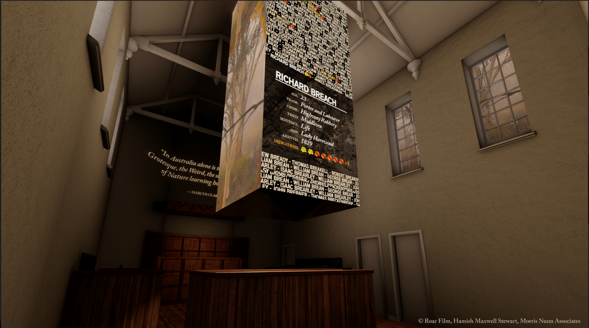

Preliminary concept image by Roar Films of suspended LED screens and LED screens mounted over the windows.