National Trust calls for audit of Canberra's mid-century modern homes 9-5-2021

Jasper Lindell

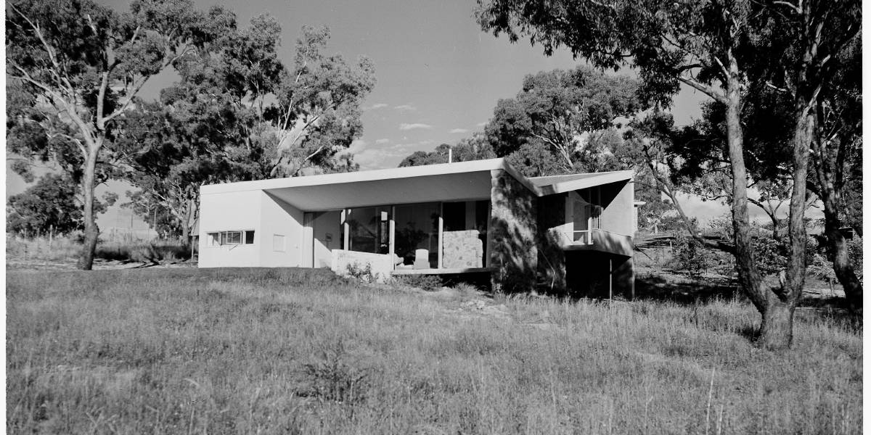
A Harry Seidler-designed mid-century home in Deakin, pictured in 1954. Picture: ACT Heritage
Canberra's mid-century modern heritage will continue to be lost unless urgent action is taken to identify and protect modernist homes from the period, the National Trust says.
The trust has called for an audit of Canberra's architect-designed mid-century homes to inform future heritage applications, which the organisation says it could complete.
The trust's ACT president, Gary Kent, said the audit would likely cover several hundred houses, many of which were flying under the radar when it came to architectural appreciation.
"There is no comprehensive record of them. There are many important architects whose houses are represented in Canberra, but there's not comprehensive listing of them," Mr Kent said.
"If we don't do the work, many of these important examples of mid-century architecture will be demolished, and so we believe an audit is essential before it's too late."
The National Trust ACT received long-term funding in the territory budget in February, and expects to sign a memorandum of understanding with the ACT government in the coming weeks about the use of the money.
Mr Kent said the funding could allow the National Trust ACT to complete the audit, with input from other stakeholders and experts in Canberra.
Not all houses assessed in an audit would be recommended for heritage registration, Mr Kent said.
"What we're hoping the survey would identify is innovative designs. Even when they were built [these houses] were regarded as cutting edge, and reflective of Canberra's place in the world, as an internationally known planned city," he said.
"These houses are actually part of the aspects of Canberra as a planned city."
Mid-century modern homes were built for many prominent Canberra citizens by some of Australia's leading architects. The style is typified by flat planes, clean lines and a focus on functionality.
ACT Heritage Council chair Dr Kenneth Heffernan welcomed the idea, saying a thematic study of modern period homes could strengthen the territory's heritage system.
"In recent times of course the increase of community interest in mid-century architecture and design means that we have to keep on the front foot and I think that would be a useful contribution to the comparative assessment work of the Heritage Council," Dr Heffernan said.
"That would also put the National Trust in the position to make strong nominations, because they would have a better grounding to pick the best places."
Dr Heffernan said an audit like the one proposed by the National Trust could help save putting effort into heritage nominations that would not make the grade.
"We've always got a lot of work on our plate, and nominations coming through. The better written they are in the first place, the faster the process of getting them protected. I think it's a commendable targeting of resources by the National Trust," he said.
READ MORE:
- Canberra Modern takes capital's modernist architecture to Modernism Week in Palm Springs, California
- Developers should engage earlier on heritage issues: ACT Heritage Council chair
- Enrico Taglietti's Cinema Center on Bunda Street protected by ACT Heritage Council
Adding private homes to the ACT heritage register can put considerable strain on the Heritage Council's resources, as owners can fight the registration.
The ACT Civil and Administrative Tribunal in 2019 struck a Deakin home designed by pioneering modernist architect Harry Seidler from the register after its owner appealed the home's listing.
The tribunal found the home did not satisfy any heritage significance criteria because it had been extensively modified.
Then Heritage Council chair David Flannery said the council was comfortable with the decision.
"It's not unusual when it's a private house, that a decision to register a private house is appealed," Mr Flannery said at the time.
The number of nominations made to the Heritage Council has also increased sharply, with submissions rising by a third in the last financial year.
More than 900 nominations were made to the council in 2019-20, up from 663 nominations in the previous financial year.
https://www.canberratimes.com.au/story/7243083/call-to-audit-canberras-mid-century-modern-houses-before-its-too-late/?cs=14264

