

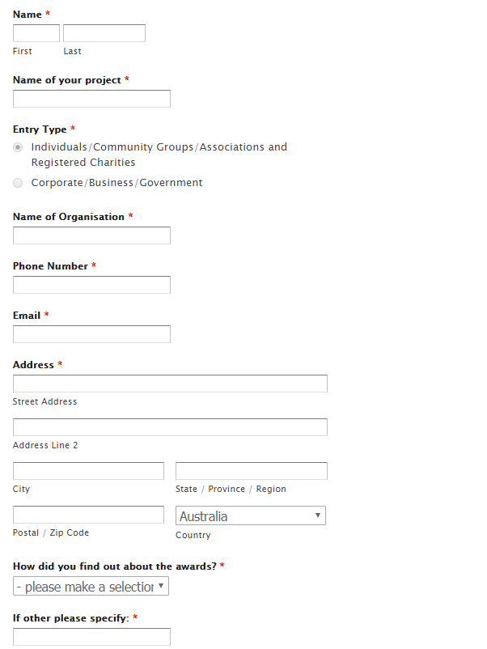

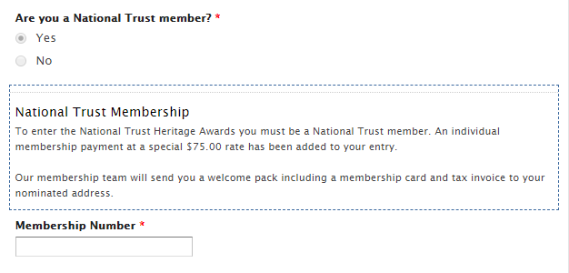

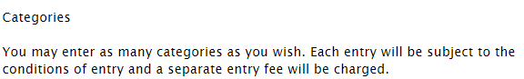

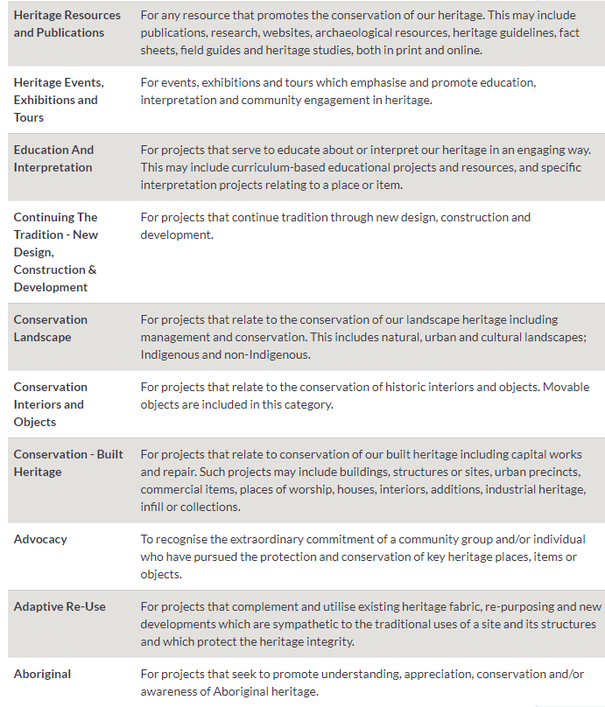

Cost of project:

Time frame of project:

Name of individuals/ companies who worked on the project:

Project short description:

Project detailed description: