

**Hobart Convict Penitentiary Historic Site**

**School Tour Booking Form**

|  |  |
| --- | --- |
| **Requested Tour Date:**  *(Please note this is subject to confirmation)* |  |

|  |  |  |  |  |  |
| --- | --- | --- | --- | --- | --- |
|  | **Monday** | **Tuesday** | **Wednesday** | **Thursday** | **Friday** |
| 9.00am |  |  |  |  |  |
| 10.00am |  |  | **X** | **X** | **X** |
| 11.00am |  |  | **X** | **X** | **X** |
| 12.00pm |  |  | **X** | **X** | **X** |
| 1.00pm |  |  | **X** | **X** | **X** |
| 2.00pm |  |  | **X** | **X** | **X** |

|  |  |
| --- | --- |
| **School Information** | |
| **School** |  |
| **Phone** |  |
| **Email** |  |
| **Address** |  |

|  |  |
| --- | --- |
| **Attending Teacher Contact Information** | |
| **Name** |  |
| **Phone** |  |
| **Email** |  |

|  |  |
| --- | --- |
| **Tour Information** | |
| **Year Level** |  |
| **Number of Students** |  |
| **Number of Staff**  **1 Staff per 10 students complimentary** |  |

|  |
| --- |
| **As the site has uneven surfaces and some narrow, steep stairs, please inform us of the number of students with mobility issues so that we can arrange alternative access points and routes through the site:** |
|  |

**FINANCIAL:**

**$10 per student.   
One Staff member per 10 students free of charge.**

**The features of a tour of the site of the Hobart Convict Penitentiary include:**

* The site of the Penitentiary as it was in 1821
* The Solitary Confinement cells under the pews in the Chapel
* The Penitentiary Chapel, construction commenced in 1831
* The underground tunnels, convict-built in 1860
* Clock tower entrance including the Church bell
* 1860 conversion to the Supreme Criminal Court
* Viewing of the 35 minute film Pandemonium (recommended for secondary classes only)

**CONTENT WARNING:**

The immersive film experience *Pandemonium* is not recommended for primary aged students. It includes some scenes which may be unsettling for young viewers and strong themes relevant to the convict era.

**Please indicate your preference below:**

**Yes – Please remove the film screening from our tour.**

**No – We would like the film to be included on our tour.**

**CURRICULUM FOCUS:**

**Where possible, our guides will attempt to curate the tour to fit in with curriculum requirements.**

**Please select from the accompanying list below OR note your requirements here:**

|  |
| --- |
|  |

**DIRECTIONS:**

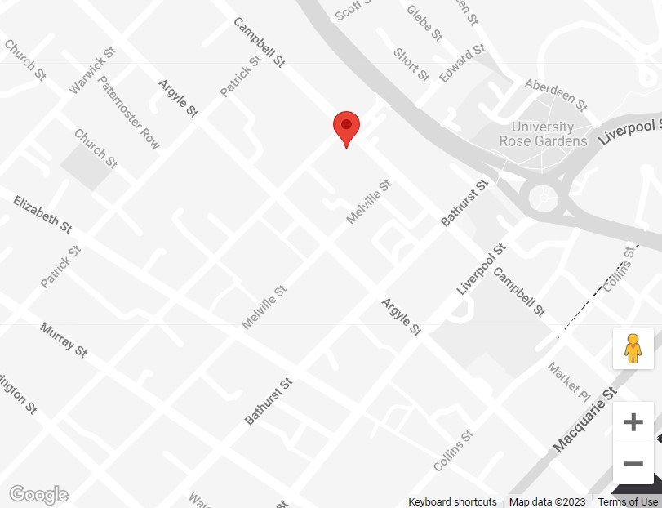

**LOCATION:**On the corner of Brisbane and Campbell Streets, Hobart.

Main door entry from Campbell Street

Bus parking available on Brisbane Street

**SITE CONTACT DETAILS:**

Contact Phone: (03) 6231 0911

Contact Email: penitentiary.chapel@nationaltrust.org.au

**PROPERTY MANAGER CONTACT DETAILS:**

Name: Jim Ward

Phone: 0439 043 472

Email: [j.ward@national](mailto:j.ward@national)trusttas.org.au

**Please highlight the relevant curriculum focuses:**

**CURRICULUM FOCUS – PRIMARY OR SECONDARY**

*Grade 5/6 HASS – Australian communities – their past, present and possible futures.*

*The Year 5 curriculum focuses on colonial Australia in the 1800’s and aspects of the social, economic, political and environmental causes and effects of Australia’s development.*

* Local history
* The age of exploration, including different explorers
* The colonial history and settlement of Van Diemen’s Land
* Life in early colonial Tasmania
* Child convicts including the trades the convict boys were taught
* The role of convicts in colonial society/the work they carried out
* Punishments including solitary confinement, the treadmill, leg irons and floggings
* The Transportation system and the power of authority
* The role and function of religion in colonial society
* Rules and the Law in colonial society

**CURRICULUM FOCUS – SECONDARY**

*Year 9 HISTORY The making of the modern world.   
The Year 9 curriculum provides a study of the history of the making of the modern world from 1750 to 1918. This was a period of industrialization and rapid change in the ways people lived, worked and thought. It was an era of nationalism and imperialism, and the colonization of Australia and the expansion of European power*

|  |
| --- |
| * The history/settlement of Colonial Van Diemen's Land including key historical figures such as Governor Arthur * What life was like for convicts in Van Diemen's Land; how they were classified, their work and their role in society * The complexity of survival in the early Colony * The impact of colonization on indigenous Tasmanians * Rules and Laws/the Justice System in Van Diemen's Land including death sentences passed in the Supreme Criminal Courtroom (Court Room One in the converted Penitentiary Chapel) |

**CURRICULUM FOCUS – SENIOR SECONDARY**

*Year 11/12 MODERN HISTORY*

*Year 11/12 LEGAL STUDIES*